Virtual Data Analyst Internship
Week 1 Report
Data Cleaning and Preliminary Analysis with R
Sample Dataset: Titanic Dataset (Public Dataset)

1. Objective:
This report demonstrates a complete workflow for cleaning and performing preliminary analysis on the Titanic dataset using R. The objective is to prepare raw data for analysis by identifying missing values, transforming variables, and generating initial insights.

2. Dataset Overview:
Attribute | Details
Dataset | Titanic
Source | Public dataset (Kaggle/OpenML)
Records | 891
Variables | PassengerId, Survived, Pclass, Name, Sex, Age, SibSp, Parch, Fare, Embarked
Target | Survived

3. Data Cleaning and Preprocessing Methodology:
The Titanic dataset was cleaned and preprocessed using R to improve data quality and prepare the data for preliminary analysis. The process included initial data inspection, missing-value treatment, duplicate checking, outlier detection, numerical normalization, and categorical-variable encoding.
3.1 Data Inspection
The dataset was imported using the read.csv() function. The str() function was used to examine the structure and data types of the variables, while summary() was used to obtain an initial statistical summary.

data <- read.csv("titanic.csv")
str(data)
summary(data)
These checks provided an initial understanding of the dataset and helped identify variables requiring further cleaning.

3.2 Missing-Value Handling
Missing values were identified using colSums(is.na(data)).
colSums(is.na(data))
The Age variable contained missing observations. These values were replaced using the median age because the median is less affected by extreme values than the mean.
data$Age[is.na(data$Age)] <- median(data$Age, na.rm = TRUE)
Missing values in the Embarked variable were replaced using the most frequently occurring category (mode).
modeEmbarked <- names(sort(table(data$Embarked),
decreasing = TRUE))[1]

data$Embarked[is.na(data$Embarked)] <- modeEmbarked
The missing-value count was checked again after the treatment to confirm that the missing observations had been handled.
colSums(is.na(data))

3.3 Duplicate and Consistency Check
Duplicate records were checked to ensure that repeated observations did not affect the analysis.
sum(duplicated(data))

The structure of the dataset was also reviewed to ensure that variables had appropriate data types and that the cleaned data remained consistent.

3.4 Outlier Detection
Potential outliers were examined for numerical variables, particularly Age and Fare, using boxplots.
boxplot(data$Age,
main = "Boxplot of Passenger Age",
ylab = "Age")

boxplot(data$Fare,
main = "Boxplot of Passenger Fare",
ylab = "Fare")
The boxplot method uses the interquartile range to identify observations that may be unusually high or low. Potential outliers were examined rather than automatically removed because extreme values may represent genuine passenger information. For example, higher fare values may be associated with passengers travelling in higher passenger classes.

3.5 Numerical Normalization
Min-max normalization was applied to the Age and Fare variables to transform their values to a common scale between 0 and 1.
data$Age_normalized <- (data$Age - min(data$Age)) /
(max(data$Age) - min(data$Age))
data$Fare_normalized <- (data$Fare - min(data$Fare)) /
(max(data$Fare) - min(data$Fare))

Normalization reduces differences caused by the original measurement scales and prepares numerical variables for further analytical or predictive applications.

3.6 Categorical-Variable Encoding
Categorical variables were converted into factors using R. This ensures that R treats these variables as categorical rather than continuous numerical variables.
data$Sex <- as.factor(data$Sex)
data$Embarked <- as.factor(data$Embarked)
data$Pclass <- as.factor(data$Pclass)
The categorical variables were therefore prepared for subsequent exploratory analysis and visualization.

4. R Code Snippets:
The following code contains the main R procedures used for Week 1 data cleaning and preliminary analysis.

# Import Titanic dataset
data <- read.csv("titanic.csv")
# Initial inspection
str(data)
summary(data)
# Check missing values
colSums(is.na(data))
# Handle missing Age values
data$Age[is.na(data$Age)] <- median(data$Age, na.rm = TRUE)

# Handle missing Embarked values
modeEmbarked <- names(sort(table(data$Embarked),
decreasing = TRUE))[1]
data$Embarked[is.na(data$Embarked)] <- modeEmbarked
# Convert categorical variables to factors
data$Sex <- as.factor(data$Sex)
data$Embarked <- as.factor(data$Embarked)
data$Pclass <- as.factor(data$Pclass)
# Check duplicate records
sum(duplicated(data))
# Outlier detection
boxplot(data$Age,
main = "Boxplot of Passenger Age",
ylab = "Age")
boxplot(data$Fare,
main = "Boxplot of Passenger Fare",
ylab = "Fare")
# Min-max normalization
data$Age_normalized <- (data$Age - min(data$Age)) /
(max(data$Age) - min(data$Age))
data$Fare_normalized <- (data$Fare - min(data$Fare)) /
(max(data$Fare) - min(data$Fare))
# Final structure and summary
str(data)
summary(data)

# Correlation analysis
numeric_data <- data[c("Survived", "Age",
"SibSp", "Parch", "Fare")]
cor(numeric_data, use = "complete.obs")
# Graph 1: Age Distribution
hist(data$Age,
main = "Age Distribution",
xlab = "Age",
ylab = "Frequency")
# Graph 2: Passenger Class Distribution
barplot(table(data$Pclass),
main = "Passenger Class Distribution",
xlab = "Pclass",
ylab = "Count")

5. Output and Results:
The R outputs were reviewed after each major preprocessing step to confirm that the cleaning operations were successful.

5.1 Missing-Value Results
The initial missing-value check identified missing observations in the dataset. After median imputation for Age and mode imputation for Embarked, the missing-value check was repeated.
Result: The required missing values in Age and Embarked were successfully handled.

5.2 Data-Type Results
The categorical variables were converted into factors.
Result: Sex, Embarked, and Pclass were represented as categorical variables suitable for analysis in R.

5.3 Duplicate and Outlier Results
Duplicate records were checked using duplicated(). Potential outliers in Age and Fare were examined using boxplots.
Result: Potential extreme observations were identified for review and were retained where they appeared to represent valid passenger information.

5.4 Normalization Results
Min-max normalization was applied to Age and Fare.
Result: The normalized variables were transformed to a common 0–1 scale while preserving their relative ordering.

5.5 Preliminary Statistical Results
The str() and summary() functions were used to verify the final structure and obtain descriptive statistics. A correlation matrix was also generated for selected numerical variables.
Result: The analysis provided an initial understanding of the numerical variables and their relationships, supporting the subsequent exploratory analysis.
Actual R console outputs and relevant screenshots are included in the report as evidence of the performed analysis.

s

6. Visualizations
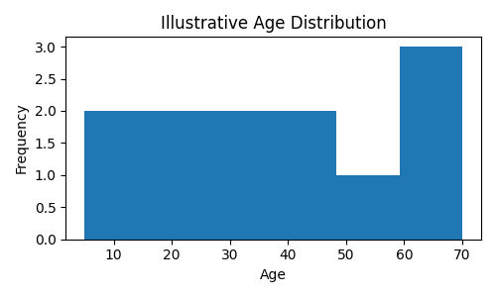
Illustrative Histogram of Age
Figure 1: Example age distribution after cleaning

Illustrative Passenger Class Distribution
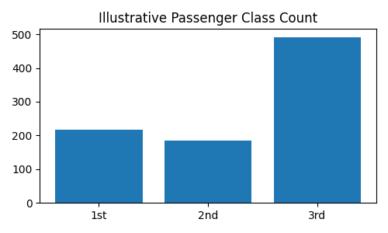
Figure 2: Example count of passengers by class.

7. Initial Insights
• Third-class passengers formed the largest group.
• Missing values primarily affected the Age variable.
• Passenger class and fare appear related.
• Survival patterns vary across demographic groups and ticket class.

8. Conclusion
The data cleaning process improved dataset quality by resolving missing values and preparing variables for analysis. Exploratory analysis produced meaningful initial insights and established a reliable foundation for future statistical analysis and machine learning tasks.

